SafeSpend Application Manual



Version 1.0

Table of Contents

**User manual** 2

**Main page** 3

Wallet Button 3

Del Button 3

Insert Money 3

Pay 3

Check Change 3

Speaker Button 3

Insert Money Screen 3

Home button 4

Record Voice 4

Scan Money 4

Add Virtual Money 4

Speaker 4

**Record Voice** 5

Microphone 5

Add to Wallet Button 5

Scan Money 6

Insert Image 6

Image Preview 6

Result Add to Wallet 6

**Money List** 7

Home Button 7

Back Button 7

Select Money 7

Money Selection 7

Home Button 7

Back Button 7

Check Button 7

No Check Button 7

Wallet Button 7

**Pay Method** 8

Microphone Button 8

**Check Change** 8

# **User manual**

This is the user manual for the Save Spend app. Some photos may vary with the final product.

# **Main page**

This is the main menu screen of the application. It has the shortcuts of the tools available in the application to manage your virtual wallet.

Below a brief description of each item from this menu:

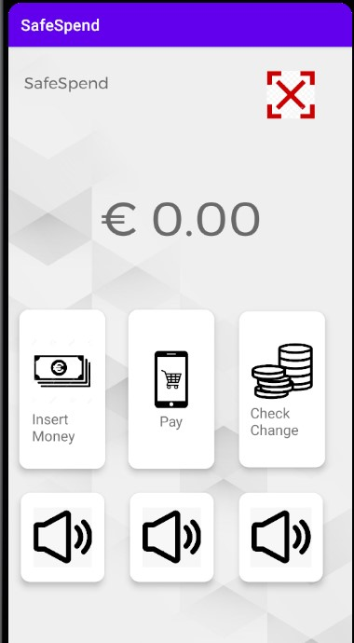

Wallet Button: shows the amount of money the user has.

Del Button**:** it is for the user to restart his wallet.

Insert Money**:** this option will open a new screen in which the user will have options to insert money in his wallet.

Pay**:** this option opens a new screen in which the user will enter the amount of the payment to be made.

Check Change**:** this option the user will see the change that must be delivered to him.

Speaker Button**:** Speaker in front of each option tells you which option the user is in.

## **Insert Money Screen**

This screen displays the options the user has to insert the money into the application.

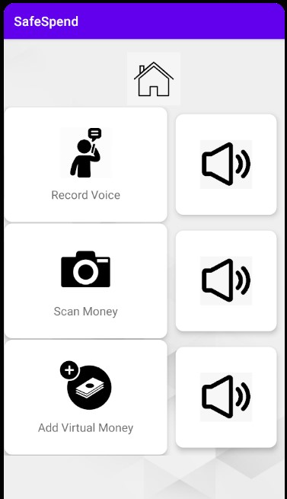Home button**:** returns to the main page.

Record Voice**:** This option the user will be able to record the value he wants to enter using his phone's microphone.

Scan Money**:** This option will open the camera so that the user can scan the money to be inserted in the wallet.

Add Virtual Money**:** This option opens a list for the user to select the money he wants to include in his wallet.

Speaker**:** Speaker in front of each option tells you which option the user is in.

# **Record Voice**

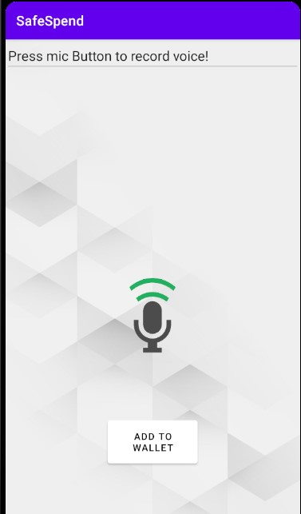

This screen shows the option to record the amount.

Microphone**:** when pressing the microphone, the user will record the value.

Add to Wallet Button**:** adds the value recorded on the microphone in the wallet.

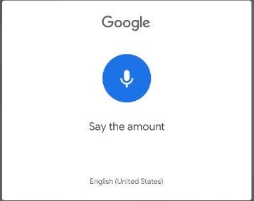

Pop Up: Pop Up that appears when the user presses the microphone, the user must press the microphone and record the desired amount.

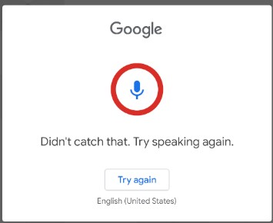

Pop Up Error: If the user is unable to record correctly, or cannot use the microphone, an error message will appear.

## **Scan Money**

This table shows the option to scan the money to be inserted into the wallet.

****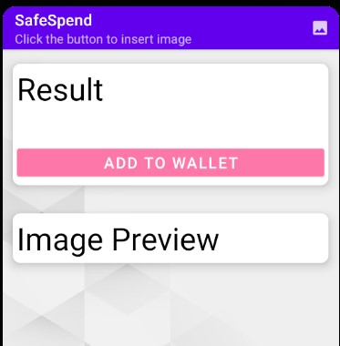

Insert Image**:** This button opens the user's cell phone camera to scan the money.

Image Preview**:** show the result of the scanner made by the user.

Result Add to Wallet**:** this option introduces the result of the scanner into the virtual wallet.

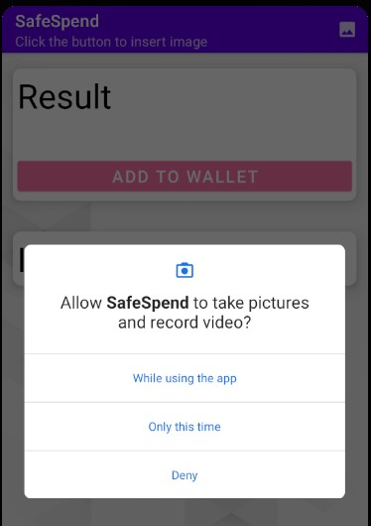

Permission scan **:** screen for the application to access the camera, the user must allow the application to access the camera in order to use the option to scan the money.

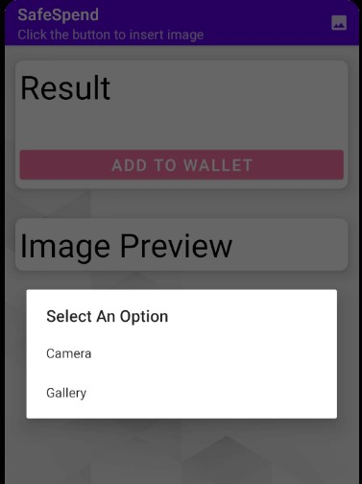

Camera**:** this screen shows the user's option to open the camera to scan the money or access the gallery with the money already saved.

# **Money List**

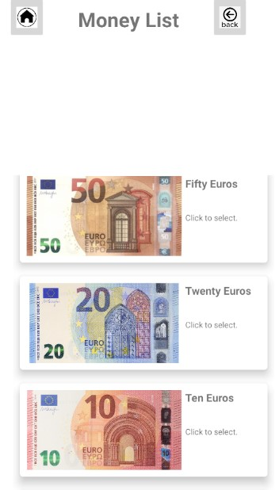

This screen shows the money list.

Home Button**:** This button returns to the main screen.

Back Button**:** This button returns to the previous screen (Insert Money).

Select Money**:** The user will be able to select the money by clicking on it, it will open another page.

## **Money Selection**

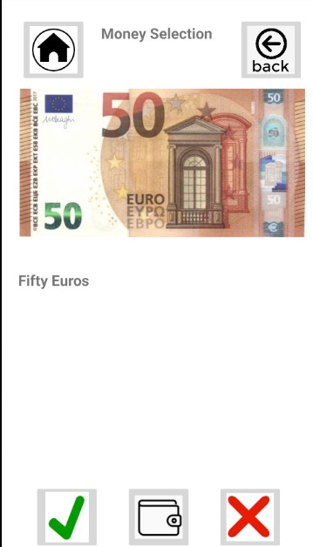Screen showing the selected money to be confirmed by the user.

Home Button**:** This button returns to the main screen.

Back Button**:** This button returns to the previous screen (Money List).

Check Button**:** Check Button: confirms the selected money and inserts it into the wallet.

No Check Button**:** negates the selection and returns to the previous page (Money List).

Wallet Button**:** display the money in the wallet.

# **Pay Method**

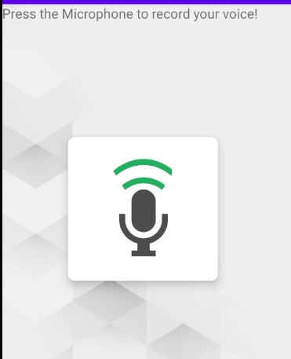

Microphone Button**:** The user uses the button microphone to record the amount to be paid.

The app will display o amount the application will show the money that must be delivered to make the payment.

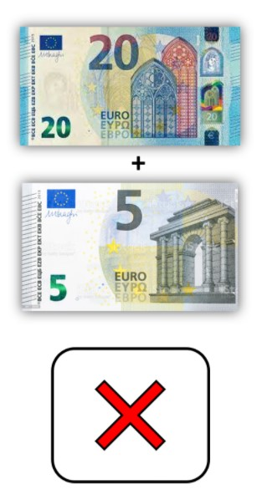

# **Check Change**

The application will show the amount to be returned to the user after payment has been made and will return to the main screen.

